**CURRICULUM VITAE**

NAGINA MUHAMMAD AFZAL

# **PERSONAL INFORMATION**

 : nimranimi0306@gmail.com

 :03060035327

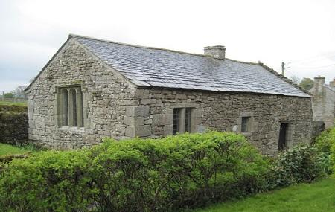 : Sec 7-A North Karachi

* DATE OF BIRTH : 20 March 1998
* CNIC NUM : 42101_8626492-6
* RELIGION : ISLAM
* MARITAL STATUS : SINGLE

**CAREER OBJECTIVE**

To obtain a position in field where I cause my qualification, abilities and experience towards achieving the goal and objectives of the organization with the chance of advancement.

**ACADEMIC QUALIFICATION**

* **MATRICULATION(SCIENCE).**
* From Board of Secondary Education Karachi.
* **INTERMEDIATE(ARTS).**
* From Board of Intermediate Education, Karachi.
* **MICROSOFT OFFICE.**
* From Aptech Computer Education North Karachi.
* **SOFTWARE ENGINEERING (3 YEAR PROGRAM).**
* From Aptech Computer Education North Karachi.
* IN 1ST Semester got **84%.**

**EXPERIENCE**

|  |  |
| --- | --- |
| **MARKETING**  **AUG 2014- MARCH 2016**  **APRIL 2016-JULY 2019**  **FEB 2019-JULY 2019**  **JULY 2019-DEC 2019** | * **2 Months in Marketing.** * **Last Act at Electronics’ (ANEX) 16 days.** * As a “**MONTESSORI TEACHER”** in STANDARD SECONDARY SCHOOL. * As a “**PRIMARY TEACHER**” in STANDARD SECONDARY SCHOOL. * As a “**INCHARGE**” in STANDARD SECONDARY SCHOOL. * As a “**PRIMARY ND SECONDARY TEACHER**” in ESCORT GRAMMAR SCHOOL. |

**REFERENCE**

* Can be furnished in request